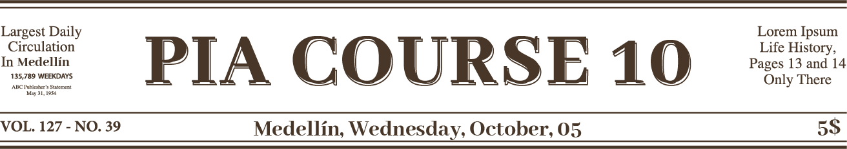

Environmental issue in your city | Image
Causes | Image
Consequences | Image
Strategies/initiatives other cities/countries have implemented to tackle this issue | Image
Strategies/initiatives being implemented in your city | Image
Conclusion with recommendations and/or final thoughts | Image

